**11. Top-Down Parser for Context-Free Grammars**

**Aim:**  
To implement a simple top-down parser for context-free grammars.

**Algorithm:**

1. Define a context-free grammar (CFG).
2. Use the NLTK CFG parser to parse the input sentence.
3. Display the parse tree if the sentence matches the grammar.

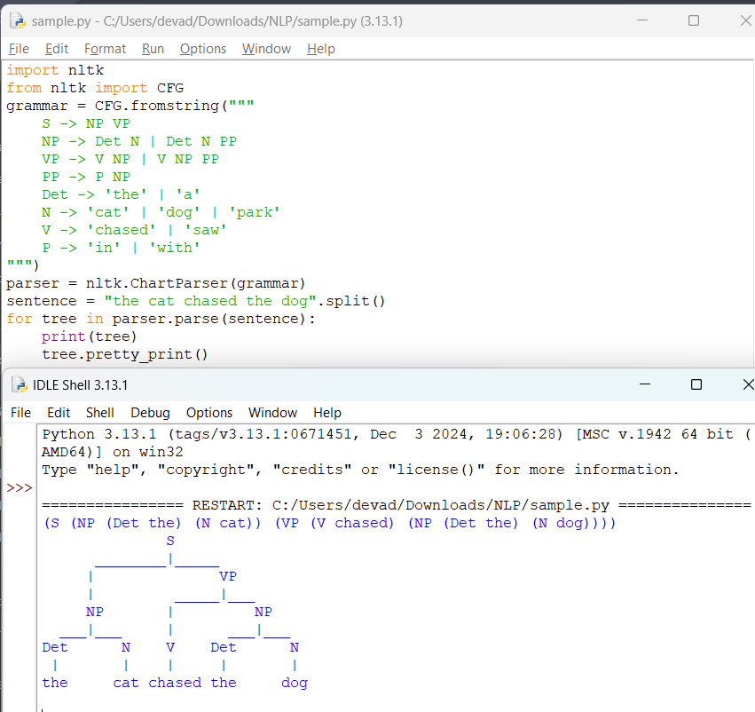

**Result:**  
The program parses sentences using a top-down approach based on the CFG.